My idea of Gradient Descent
Step 1:
Initialize the model with random weights and bias = 0 (can be altered later) and let the model run on input data, find rms error of the model form the following formula:
$$e_{rms}= \sqrt{\frac{\sum{{({out}_{model}-{out}_{real})}^{2}}}{N}}$$
This will map the given conditions to some value of error overtime making a graph of dependence of error on all weights. Now the goal is to reduce the error, meaning we can take the derivative of the weights vs. error graph to guide the model into the configuration of lowers error meaning putting it into the absolute minima of the function which should ideally be zero error.
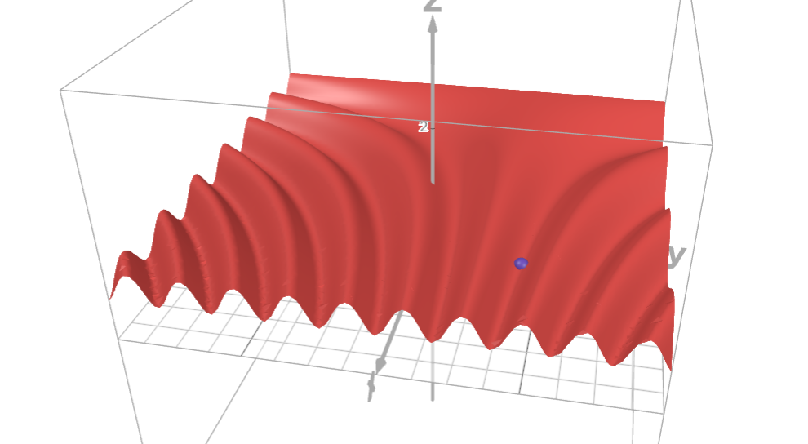
To achieve this we will try to move the weight into the configuration where its contribution to the total error is the lowest. For this we take the partial derivative of the errors with respect to the weight in question and move the point down the slope. We do this for small intervals which prevents overshooting. This requires an equation to move the point move desirably.

For this we use the partial derivative gradient descent equation:
$$w_{i}= w_{i}^{o}-f(\frac{∂e_{rms}}{∂w_{i}^{o}})$$
To acquire f(.) we need it to flatten out the curve using logarithms as a basis:
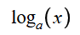
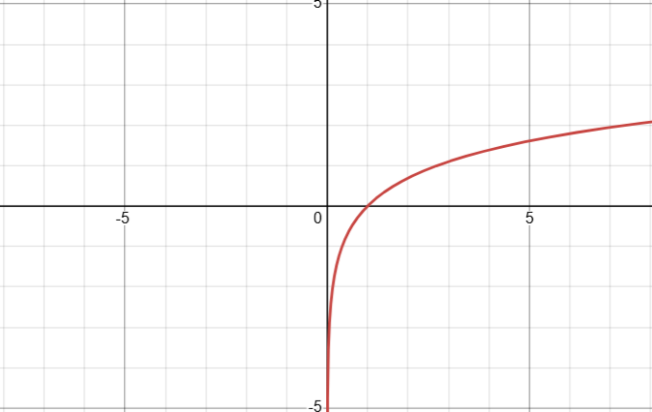
(Flattening basis)
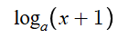
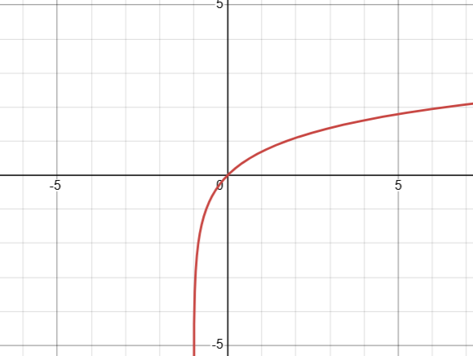
(Centralizing the curve)
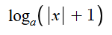
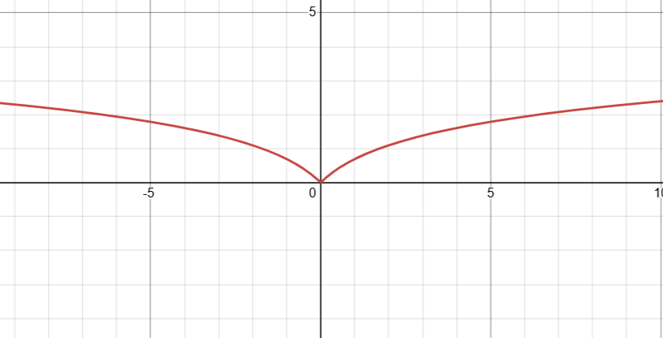
(Eliminating abnormal negative part)
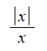
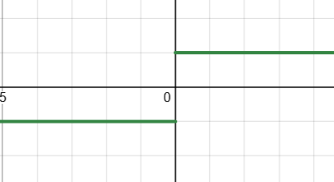
(Extracting sign of input)
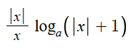
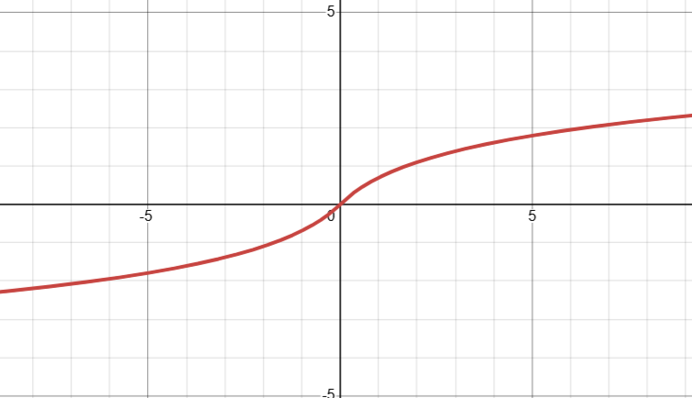
(Adding back support for negative values for controlled output)
The final function:

Alternative function:
